Health Information Forum: Getting Research into Practice, 27 January 2004

DYNAMICS AND BARRIERS, Jean Shaw, Partnerships in Health Information

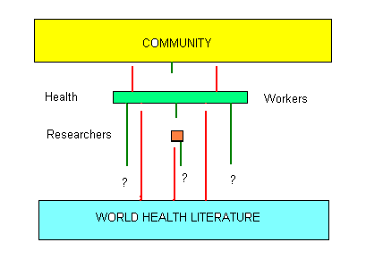

COMMUNITY
ACCESS

Barriers
- Lack of information in general,
- Illiteracy,
- Language
Bridges
- Health workers,
- Radio, entertainment, newspapers etc.
- Community leaders,
- Community network

PRACTICE - Patient Compliance

Barriers
- Lack of understanding,
- Illiteracy,
- Some traditions,
- Gender inequality

Bridges
- Community leaders

QUALITY OF INFORMATION
Depends on:
- Health promotion personnel,
- Journalists,
- Health workers mostly nurses

Barriers
- Misinformation,
- “urban myths”

FEEDBACK
- Not organized outside small communities – no national or regional self-help groups

HEALTH WORKERS

ACCESS

Barriers
- Poor learning environment,
- Little or no information on site,
- Language,
- Lack of peer contact, geographical isolation

Bridges
- CME Newsletters,
- Blue Trunk and ICN libraries,
- Health Digests, Health Bulletins
- Library outreach services
- Mobile phones,
- Computers
- Seminars
PRACTICE – Motivation

Barriers
- Workload,
- Poor salaries,
- Irrelevant information,
- Inappropriate level of language and information

Bridges
- Seminars
- Transformation of literature

QUALITY OF INFORMATION
Depends on:
- What is made available,
- Quality of transformation
- Ability of recipient to assess relevance and reliability

Barriers
- Lack of relevant research,
- Dissemination policies of researcher or research institute.
FEEDBACK TO RESEARCHERS
- Some statutory data required
- Motivation of health workers

RESEARCHERS

ACCESS
Barriers
- Poor connectivity,
- Expense of equipment and CIT,
- Lack of printed resources,
- Little relevant research

Bridges
- HINARI,
- PERI,
- Internet & applications

PRACTICE – distribution of research

Barriers
- Few in country journals,
- Difficulties of publishing in prestigious journals,
- Research done in country not automatically available,
- Dominance of MEDLINE,
- Lack of support for national databases of health literature
- Lack of recognition

Bridges
- National databases of health literature,
- Access to relevant international databases

QUALITY OF INFORMATION
Depends on:
- Research design,
- Identification of all the relevant literature,
- Critical assessment of research / other data

Barriers
- Absence of national database for health literature,
- Lack of support for African Index Medicus,
- Lack of training in basics of evidence based practice

FEEDBACK INTO WORLD LITERATURE
Depends on:
- Documenting locally produced publications, reports etc.
- Support for regional databases

SOME CONCLUSIONS
- Some of the most important people in putting research into practice are the least well served e.g. nurses - especially at the lower levels.
- Intermediaries (transformers of the literature) such as journalists and health promotion personnel need good access and quality standards
- Community leaders are not only links but role models
- Communities could do more for themselves if technology for the community is developed to allow greater exchange of experience.
- Research undertaken in a developing country must be made available to the people of that country and globally accessible
- Librarians are also important intermediaries in facilitating the flow of information e.g. Health Digests, Health Bulletins, Outreach services
- All research needs to be documented in a national health literature database – otherwise it is effectively ‘lost’
- Support for regional databases is necessary for evidence based practice on a global scale

Jean Shaw, email: jgshaw@supanet.com

